**Assignment 3.1**

* Checking whether the /user/acadgild/hadoop directory exists in the HDFS root directory.  
  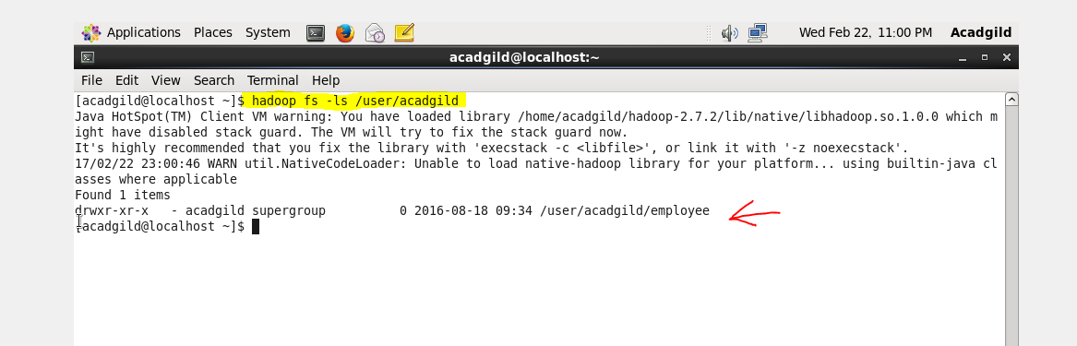  
  There is no directory named Hadoop in HDFS root directory.
* Creating the directory with the name Hadoop in the HDFS root directory path.

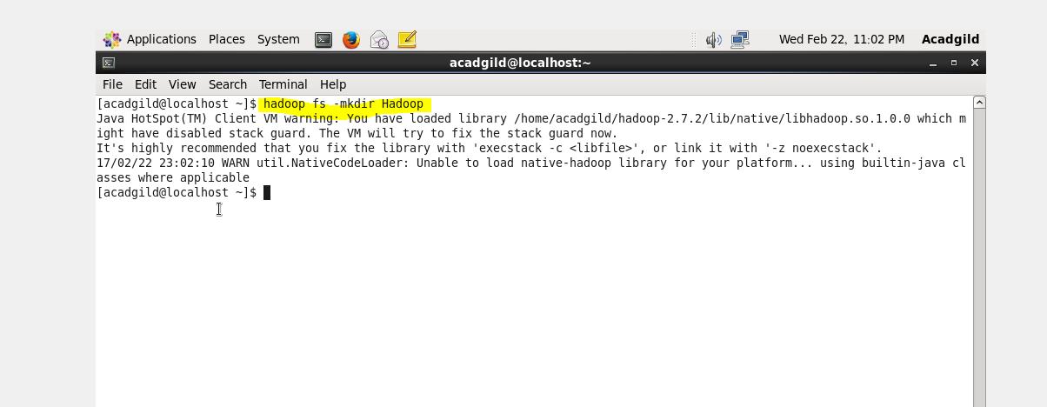  
Now the Hadoop directory is created.

* Checking whether the /user/acadgild/hadoop directory is created in the HDFS root directory.

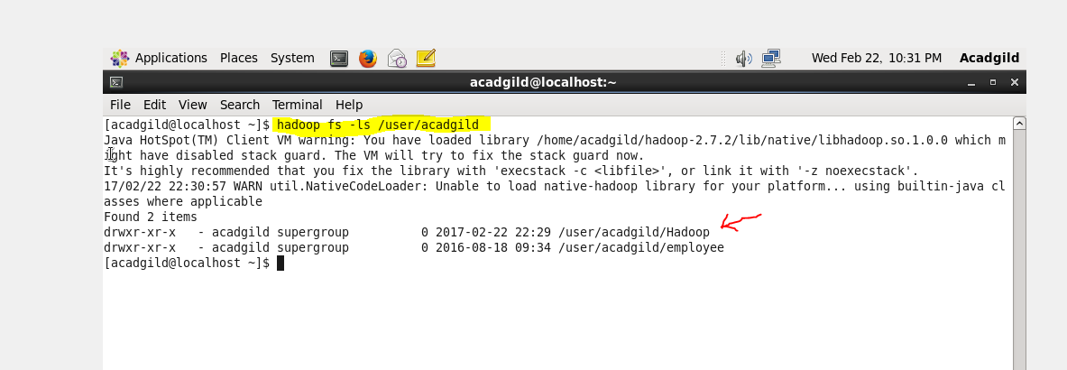

* Checking in the HDFS server.

